Chapter 8:

**Exercises**

1. Write a **SELECT** statement that returns these columns from the Invoices table:
   1. The *invoice_total* column
   2. A column that uses the **FORMAT** function to return the *invoice_total* column with 1 digit to the right of the decimal point
   3. A column that uses the **CONVERT** function to return the invoice_total column as an integer
   4. A column that uses the **CAST** function to return the *invoice_total* column as an integer

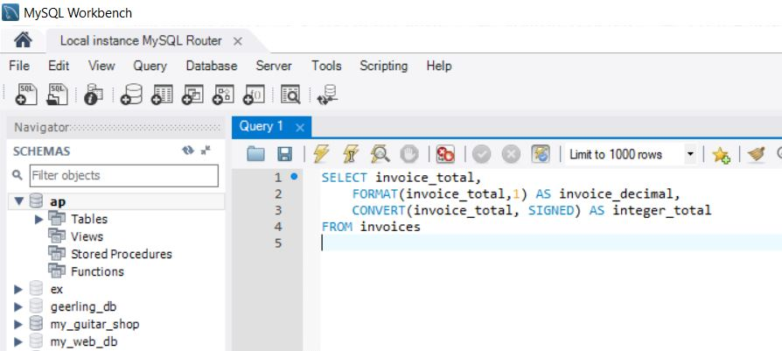

1. Write a **SELECT** statement that returns these columns from the **Invoices** table:
   1. The *invoice_date* column
   2. A column that uses the **CAST** function to return the *invoice_date* column with its full date and time
   3. A column that uses the **CAST** function to return the *invoice_date* column with just the year and the month

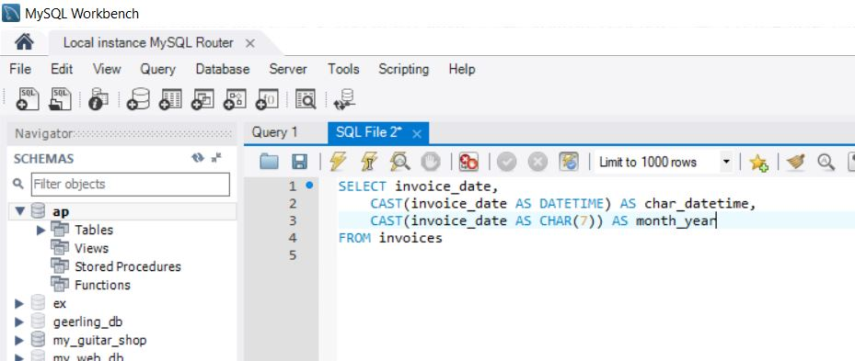

Chapter 9:

**Exercises**

1. Write a **SELECT** statement that returns these columns from the Invoices table:
   1. The *invoice_total* column
   2. A column that uses the **ROUND** function to return the *invoice_total* column with 1 decimal digit
   3. A column that uses the **ROUND** function to return the *invoice_total* column with no decimal digits

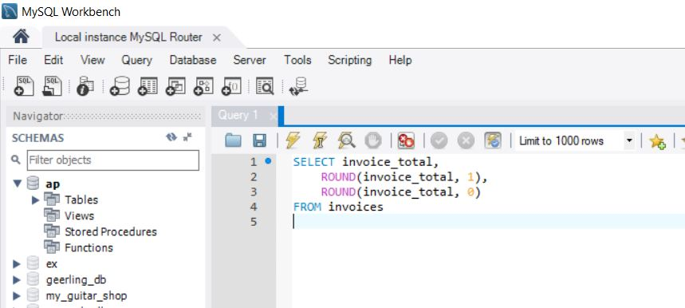

1. Write a **SELECT** statement that returns these columns from the **Date_Sample** table in the EX database:
   1. The *start_date* column
   2. A column that uses the **DATE_FORMAT** function to return the *start_date* column with its month name abbreviated and its month, day, and two-digit year separated by slashes
   3. A column that uses the **DATE_FORMAT** function to return the *start_date* column with its month and day returned as integers with no leading zeros, a two-digit year, and all date parts separated by slashes
   4. A column that uses the **DATE_FORMAT** function to return the *start_date* column with its month returned as an integer with no leading zeros, its month, day, and two-digit year separated by slashes, and its hours and minutes on a 12-hour clock with an am/pm indicator
   5. A column that uses the **DATE_FORMAT** function to return the *start_date* column with its month returned as an integer with no leading zeros, its month, day, and two-digit year separated by slashes, and its hours and minutes on a 12-hour clock with an am/pm indicator

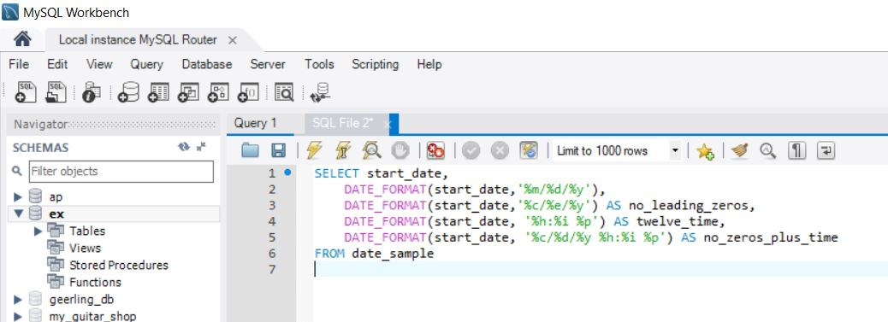

1. Write a **SELECT** statement that returns these columns from the **Vendors** table:
   1. The *vendor_name* column
   2. The *vendor_name* column in all capital letters
   3. The *vendor_phone* column
   4. A column that displays the last four digits of each phone number
   5. When you get that working right, add the columns that follow to the result set. This is more difficult because these columns require the use of functions within functions.
      1. The *vendor_phone* column with the parts of the number separated by dots, as in 555.555.5555
      2. A column that displays the second word in each vendor name if there is one and blanks if there isn’t

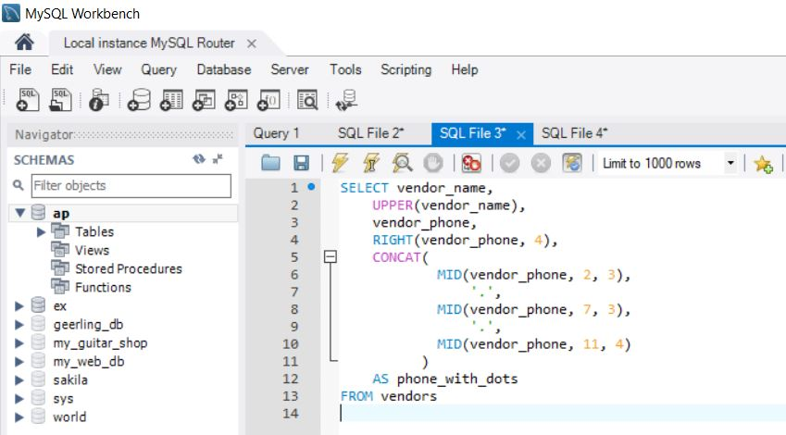

1. Write a **SELECT** statement that returns these columns from the **Invoices** table:
   1. The *invoice_number* column
   2. The *invoice_date* column
   3. The *invoice_date* column plus 30 days
   4. The *payment_date* column
   5. A column named days_to_pay that shows the number of days between the invoice date and the payment date
   6. The number of the invoice date’s month
   7. The four-digit year of the invoice date
   8. When you have this working, add a **WHERE** clause that retrieves just the invoices for the month of May based on the invoice date, not the number of the invoice month

